MWEMBEZHI SECONDARY SCHOOL
CHEMISTRY LESSON PLAN
GRADE | TOPIC | SUB TOPIC | DURRATION | DATE
11 | mole | mole | ____min | ____/___/__

RATIONALE: a mole is a number or quantities of particles e.g. atoms, ions, molecules, electrons equivalent to 6.02 x 1023(Avogadro’s constant), Applying mole concept. This is the first lesson of seven in the series. Group/ pair work and demonstration will be used to execute the lesson.
SPECIFIC OUTCOMES, LSBAT: - Describe the mole
- Appreciating the RAM and the RMM
- Describe Relative Atomic Mass and relative molecular mass.
PRE-REQUISITE SKILLS : learners have knowledge on the RAM and RMM of
Compounds.
TEACHING/ LEARNING AIDS : chemistry key points pupils book 11, periodic table.
REFFERENCES : chemistry 11
LESSON PROGRESSION
STAGE | T/L ACTIVITY | LEARNING POINTS
INTRO-  DUCTION  ____min | Revise on how to find the RAM and RMM of an element and compounds.
D  E  V  E  L  O  P  M  E  N  T  ____min | EXAMPLE;  We use the equation bellow to find the number of moles;  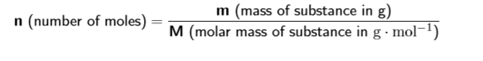  Important: Remember that when you use the equation n = m/M, the mass is always in grams (g) and molar mass is in grams per mol (g.mol − 1).  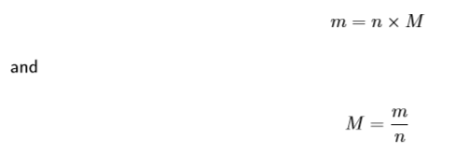  Calculate the number of moles of iron (Fe) in a 111.7 g sample.  Calculate the number of moles there are in 1kg of MgCl2. | 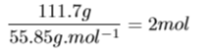  Convert mass into grams m = 1kg×1000 = 1000g  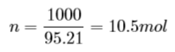  There are 10.5 moles of magnesium chloride in a 1 kg sample.
C  O  N  L  U  S  I  O  N  ____min | Go through the main points.

EVALUATION: ……………………………………………………………………………………………………………………………………………………………………………………………………………………………………………………………………………………………………………………………………………………………………………………………………….....

